Session 1Date: 20/09/2021

**Introduction to Java**

**Application and Use of language.**

Java provides a rich and wide range of API that helps programmers to develop applications. Using Java, we can develop different applications for different purposes. We can use Java technology to develop the following applications:

* Mobile App Development
* Desktop GUI Applications
* Web-based Applications
* Gaming Applications
* Big Data Technologies
* Distributed Applications
* Cloud-based Applications
* IoT Applications

**Difference between JRE,JDK JVM.**

* JDK is a software development kit whereas JRE is a software bundle that allows Java program to run, whereas JVM is an environment for executing bytecode.
* The full form of JDK is Java Development Kit, while the full form of JRE is Java Runtime Environment, while the full form of JVM is Java Virtual Machine.
* JDK is platform dependent, JRE is also platform dependent, but JVM is not platform independent.
* JDK contains tools for developing, debugging, etc. JRE contains class libraries and other supporting files, whereas software development tools are not included in JVM.
* JDK comes with the installer, on the other hand, JRE only contains the environment to execute source code whereas JVM bundled in both software JDK and JRE.

**What is Java Bytecode.**

Java bytecode is the instruction set for the Java Virtual Machine. It acts similar to an assembler which is an alias representation of a C++ code. As soon as a java program is compiled, java bytecode is generated. In more apt terms, java bytecode is the machine code in the form of a .class file. With the help of java bytecode we achieve platform independence in java.

**Why is Java Platform Independent?**

Java is a platform-independent language. In other words, you can write your code once and then run it anywhere, on any platform that provides the environment to run it. This environment is the Java Virtual Machine (JVM). The JVM should be present to execute the code. The JVM is different for each platform. In the case of Java, platform independence does not mean that you can run the code anywhere; you can run it wherever the environment is provided. This is the key point of platform independence in Java

**Installation of JDK and Eclipse**

**JDK Installation**

**Step 1)** Go to https://www.oracle.com/java/technologies/javase-downloads.html.

Click on JDK Download for Java download JDK 8.

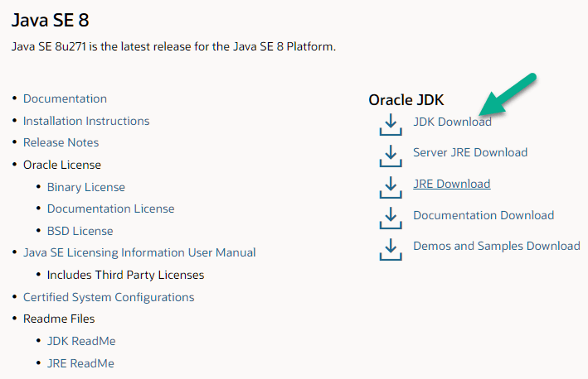

**Step 2)** Next,

1. Accept License Agreement
2. Download Java 8 JDK for your version 32 bit or JDK download 64 bit.

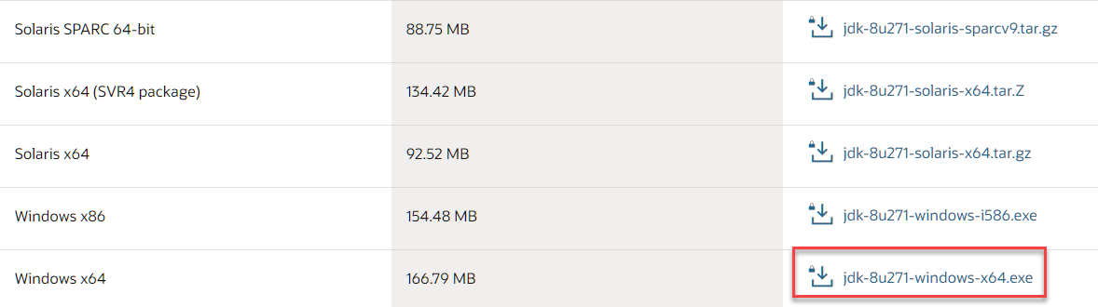

**Step 3)** When you click on the Installation link the popup will be open. Click on I reviewed and accept the Oracle Technology Network License Agreement for Oracle Java SE development kit and you will be redirected to the login page. If you don’t have an oracle account you can easily sign up by adding basics details of yours.

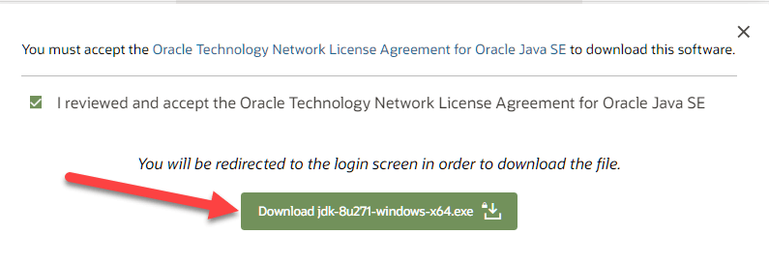

**NOTE:** You will be required to create an Oracle Account to start Java 8 download of the file.

**Step 4)** Once the Java JDK 8 download is complete, run the exe for install JDK. Click Next

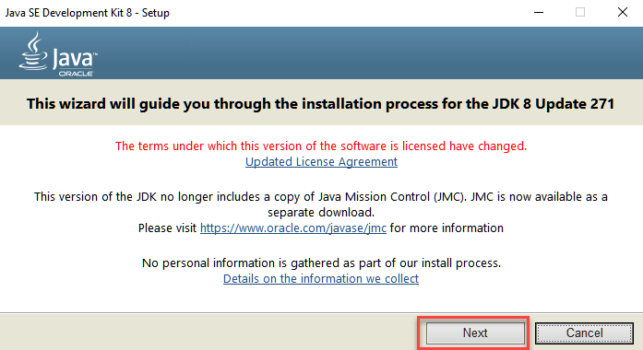

**Step 5)** Select the PATH to install Java in Windows… You can leave it Default. Click next.

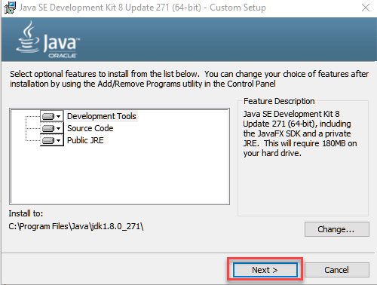

**NOTE:** Follow the onscreen instructions in succeeding steps to install Java 8 on Windows 10.

**Step 6)** Once you install Java in windows, click Close

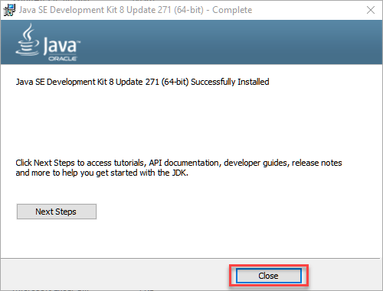

**Eclipse Installation**

**Step 1)** Installing Eclipse

Open your browser and type <https://www.eclipse.org/>

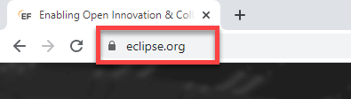

**Step 2)** Click on “Download” button.

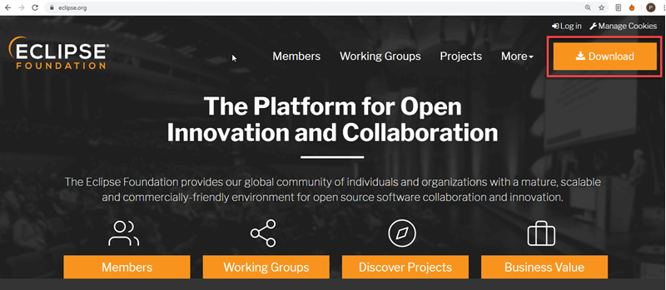

**Step 3)** Click on “Download 64 bit” button

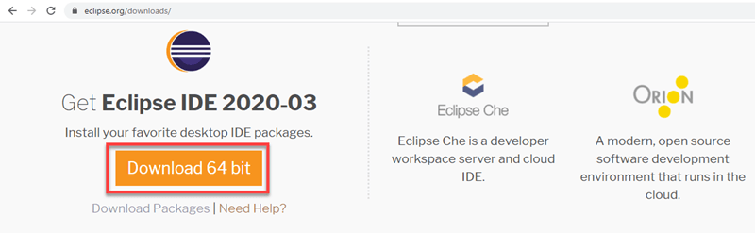

**Step 4)** Click on “Download” button

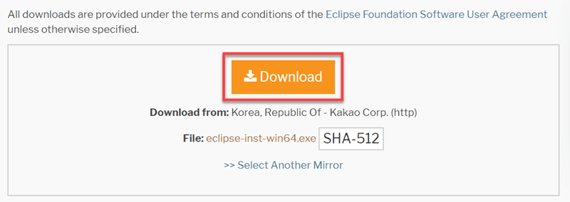

**Step 4)** Install Eclipse.

1. Click on “downloads” in Windows file explorer.
2. Click on “eclipse-inst-win64.exe” file.

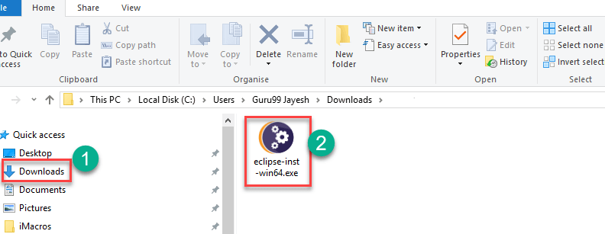

**Step 5)** Click on Run button

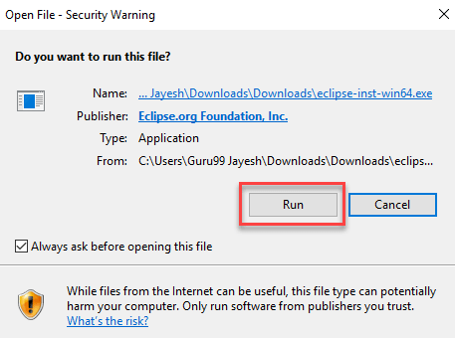

**Step 6)** Click on “Eclipse IDE for Java Developers”

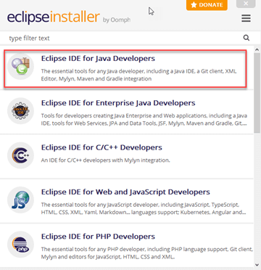

**Step 7)** Click on “INSTALL” button

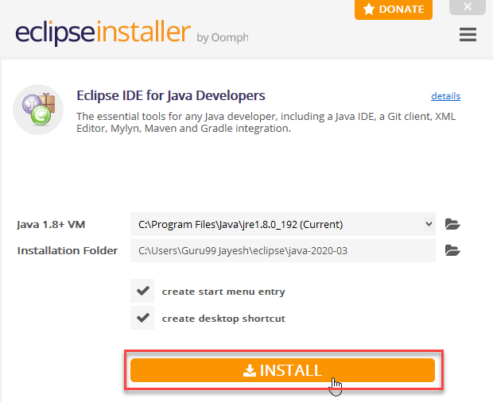

**Step 8)** Click on “LAUNCH” button.

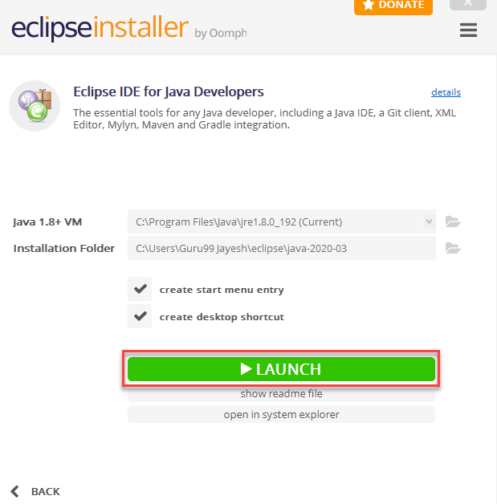

<https://www.guru99.com/install-java.html>

<https://www.guru99.com/install-eclipse-java.html>